**FSE 201: Engineering UGTA**

**UGTA Self-Selected Contribution Template**

**UGTA Name: Jacob Hreshchyshyn**

**UGTA Course: CSE205**

**Course Professor: Farideh Tadayon-Navabi**

**Session: C**

**Activity Title: Discussion Board Prompt - TEDTalk**

**Expected Points: 1**

**Activity Summary:**

For this self-selected contribution, I posted a TEDTalk of Linus Torvalds and his idea of good taste. The reason I selected this TEDTalk for a discussion post is because I felt that it was a good way of presenting ideologies on software design so that students can try to look a bit further past the Java syntax that is being explored and to begin thinking about the bigger picture. However, I wanted to keep the talk grounded in the concepts of CSE205 by asking questions that asked them to represent good taste in Java. This discussion post was made in the CSE205 class Discord server, which is managed by the instructor and class TA’s. Unfortunately, due to the size of the class and the layout of the Discord server, I did not get many people to converse about the TEDTalk. One student mentioned that he had watched the talk, but was unable to comment on the talk immediately. This indicates that some students were certainly willing to discuss the talk, but that its presentation may have been off. I think that the post might have generated more discussion had this been presented in another format, like in Canvas, or in a separate Discord channel. To be clear, I posted this discussion in the general channel since I felt that this would be the best channel for people to see the post, reply to it, and generate more responses as other people viewed other replies. Instead, after the first reply regarding the post, people posted other questions not related to the talk. Should I make a similar post in the future, I’ll do so in a dedicated discussion channel.

**Activity Supporting Materials and Documentation:**

**Discussion Post:**

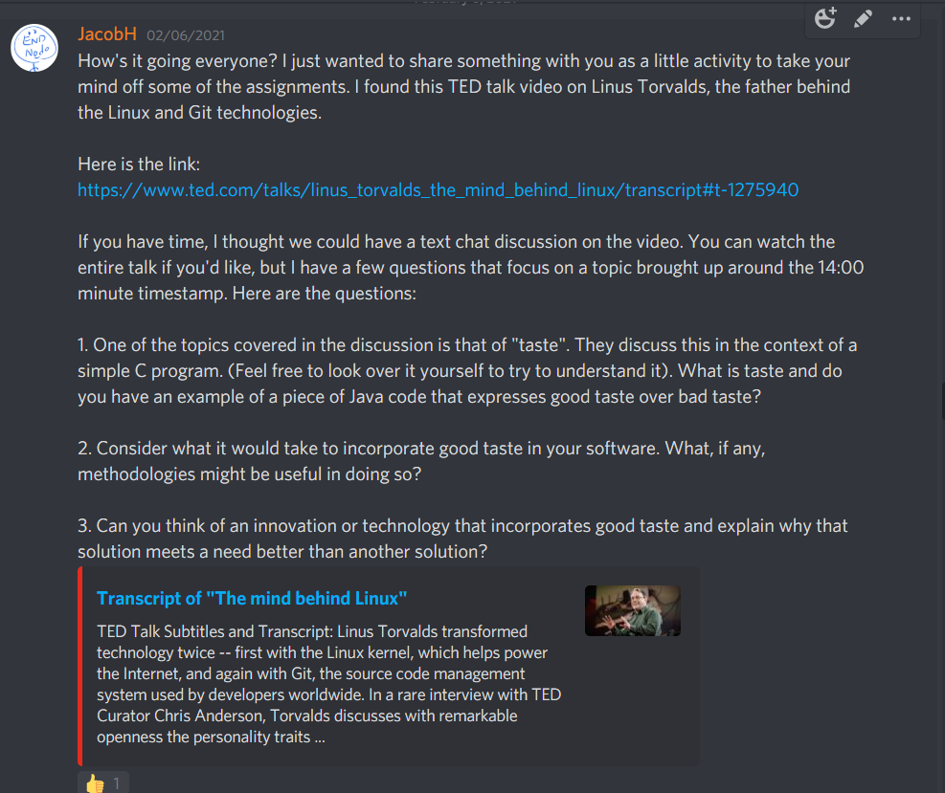

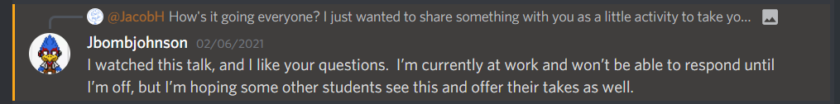

**Link to TEDTalk:**

https://www.ted.com/talks/linus_torvalds_the_mind_behind_linux